Capstone Project 2 — ART
Advanced Generative AI
Objective
The objective of this project is to design alternative cover artwork for iconic media using a fully self-hosted image generation workflow.
All images were generated locally, without using any public image generation services or APIs.
The project includes:
- One book cover
- One audio album cover (Compact Disc)

Original Works
1. Book (Original)
- Title: The Great Gatsby
- Author: F. Scott Fitzgerald
- Year: 1925
- Medium: Book cover
The original cover is used only as a visual reference for comparison purposes.
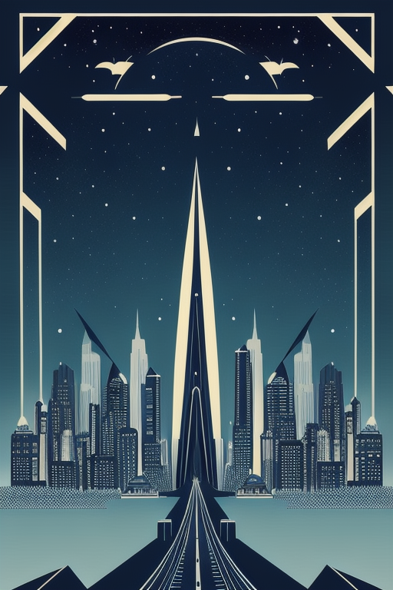
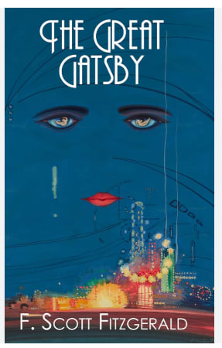

2. Audio Album (Original)
- Album: The Dark Side of the Moon
- Artist: Pink Floyd
- Year: 1973
- Medium: Compact Disc
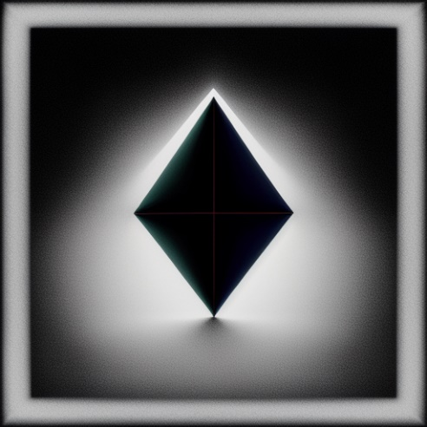
The original album cover is referenced due to its iconic minimalist and symbolic design.
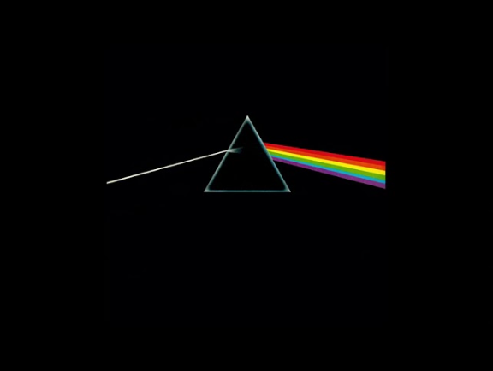
AI-Generated Works
1. AI-Generated Book Cover
- Format: Book
- Resolution: 512 × 768
- Concept:
A modern reinterpretation inspired by art-deco aesthetics, featuring a symbolic night cityscape and surreal visual elements.
Typography was intentionally excluded to avoid diffusion-based text artifacts.

2. AI-Generated Audio Album Cover (CD)
- Format: Compact Disc
- Resolution: 512 × 512
- Concept:
A modern AI-generated reinterpretation inspired by The Dark Side of the Moon, preserving the symbolic prism/light concept while avoiding direct replication of the original artwork.

Workflow Description
A node-based workflow was implemented using ComfyUI, ensuring transparency and reproducibility.
Workflow stages:
- Text prompts encoded using CLIP
- Latent space initialization
- Diffusion sampling using KSampler
- Latent decoding via VAE
- Local image saving
The workflow was fully executed offline on a local machine.
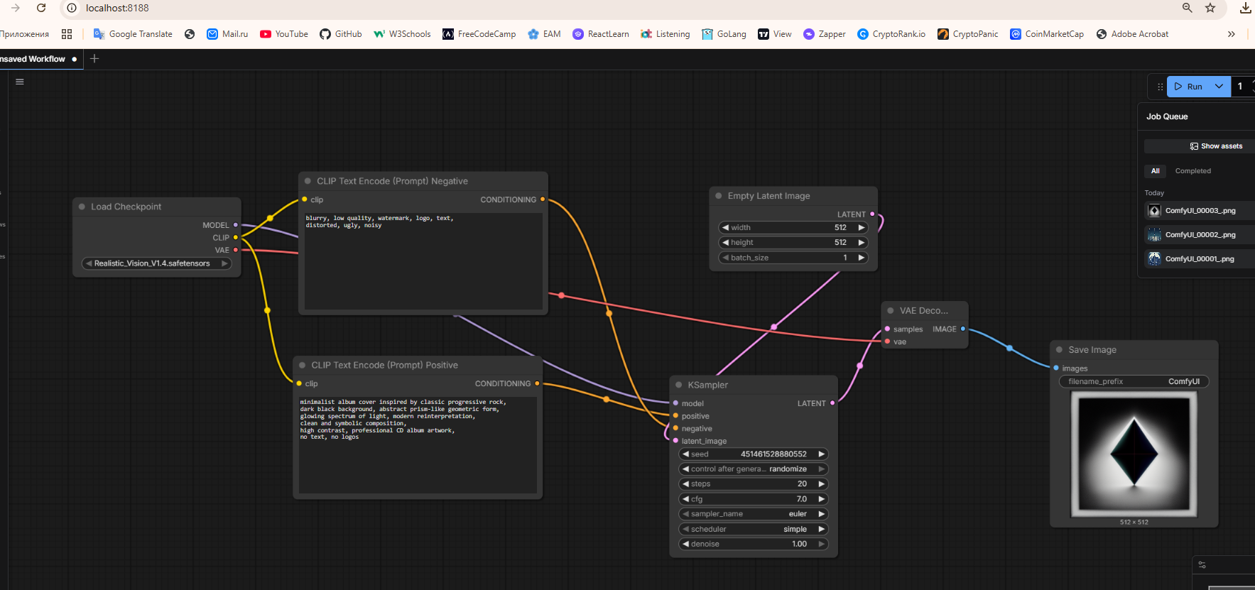

Image Generation Model
- Model: Stable Diffusion 1.5 (Realistic Vision v1.4)
- Base Architecture: Stable Diffusion 1.5
- Format: .safetensors
- Source: Hugging Face (open-weight checkpoint)
- Inference Mode: CPU-only, local execution

LoRAs / Adapters / Extensions
- LoRAs: None
- Adapters: None
- Extensions: None
Only the base model was used to ensure reproducibility and simplicity.

Technical Generation Details
Parameter | Value
Sampler | Euler a
Steps | 20
CFG Scale | 7
Seed | Fixed (for reproducibility)
Book Resolution | 512 × 768
CD Resolution | 512 × 512

Prompts Used
Book Cover — Positive Prompt
art deco inspired illustrated book cover,
deep blue night sky, stylized city skyline,
symbolic glowing eyes in the sky,
elegant, minimalist, clean composition,
professional book cover illustration, no text
CD Album Cover — Positive Prompt
minimalist album cover inspired by classic progressive rock,
dark black background, abstract prism-like geometric form,
glowing spectrum of light, modern reinterpretation,
clean and symbolic composition,
high contrast, professional CD album artwork,
no text, no logos
Negative Prompt (All Generations)
blurry, low quality, watermark, logo, text,
distorted, ugly, noisy

Pipeline Screenshots
Screenshots were captured after execution to demonstrate the complete workflow:
- Full ComfyUI node graph
- KSampler configuration (steps, CFG, sampler, seed)

Resources Used
- WebUI: ComfyUI
- Execution Mode: Local, self-hosted
- Hardware:
  - CPU-only system
  - No dedicated GPU (Intel integrated graphics)
- Operating System: Windows
- Internet Usage: Model download only (no cloud inference)
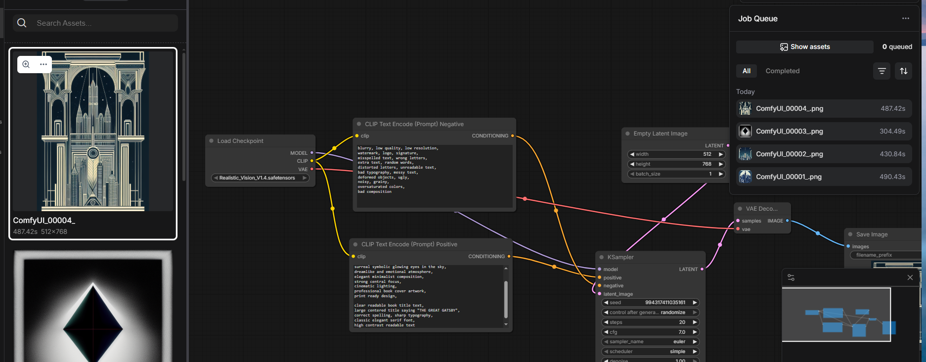
Conclusion
This project successfully demonstrates a fully self-hosted generative AI workflow for media cover design.

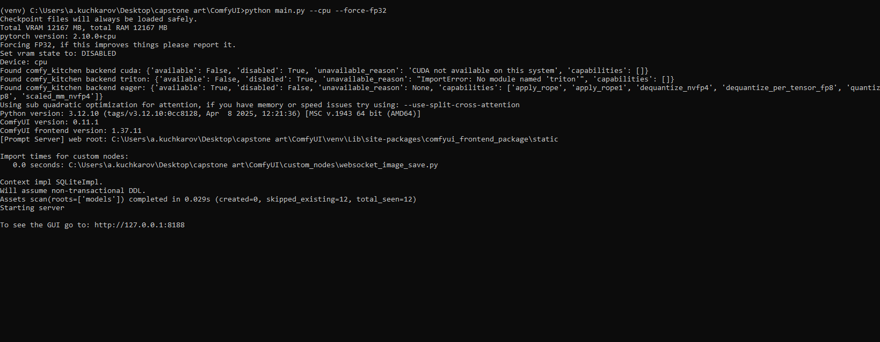
All requirements were satisfied, including offline execution, workflow transparency, and reproducibility, making the solution suitable for academic evaluation in Advanced Generative AI.

Github: https://github.com/azizkuchkarov/cap.stone-pr-2-adv.gen.ai

